1. If I find Covariance between same variable what will be the output? What will be correlation coefficient?

* Output = 0;
* Correlation Coefficient = 0.

2. Assume I have a set of numbers. The mean, median and mode of the set of numbers are equal. If I draw a Frequency plot of individual distinct numbers, how would the plot look like?

* 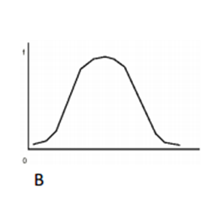

3. If the scores for a given sample distribution are: 32 32 35 36 37 38 38 39 39 39 40 40 42 45 Find the Variance and The Standard Deviation.

* Standard Deviation = 3.53;
* Variance = 12.46

Data Analytics

2. The following table shows percent variations of two financial indices, the NYSE (New York Stock Exchange) and the NASDAQ composite (National Association of Securities Dealers Automated Quotation) in 10 consecutive days:

Use a suitable measure to quantify the dependence between the variations of the two indices and comment on the result.

* 0.8278